ST ALBERT’S MISSION HOSPITAL  Mobile: 0779 718 688- Med Sup  0772 404 525 - Admin  E-mail: tsaizi.st@gmail.com  jmusariri.ima@gmail.com  joemakazah@gmail.com | 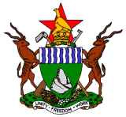  ZIMBABWE | REFERENCE:  MINISTRY OF HEALTH AND  CHILD WELFARE  St Albert’s Mission Hospital  Private Bag 9047  Centenary  ZIMBABWE
2nd April 2018

Ref: Grateful for the funds for urgent medicines and sundries from BHA

Dear Friends at BHA,
Greetings from St Albert’s Mission Hospital we are all very grateful for the funds you availed us to buy medicines and medical sundries which were out of stock. We had a relief of the urgently needed medicines when you came to our help.

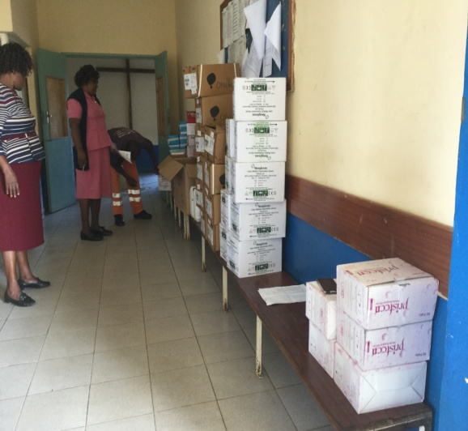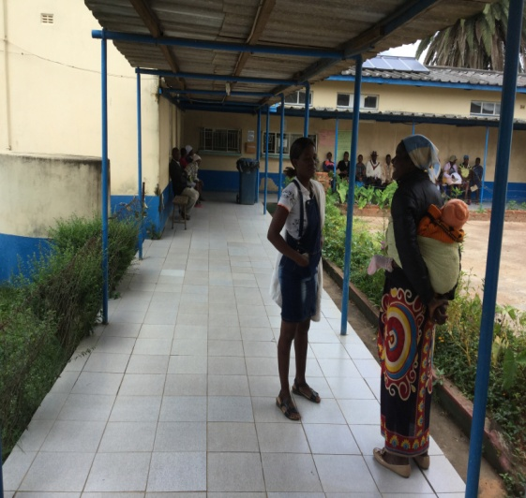
Taking stock of purchased medicines Patients waiting to pick up medicines
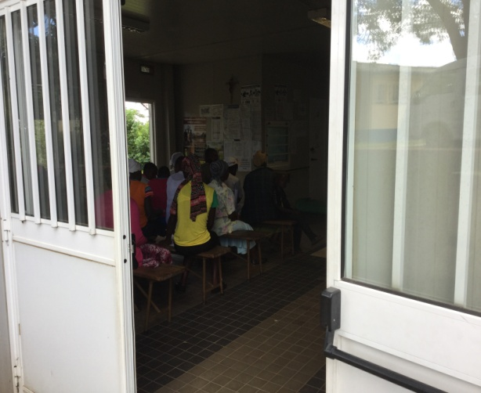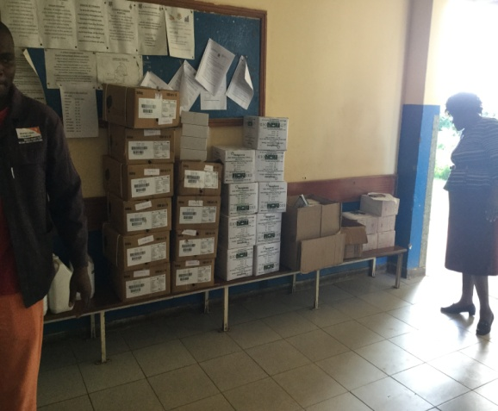
OPD patients awaiting consultations Intravenous fluids were bought
Having purchased the medicines for the $5055USD you availed us the gap was briefly closed.

We were able to resuscitate patients and to treat them. The political and economic environment is extremely unfavorable for health institutions. Thank you for the care, concern and understanding.

We always are fed on promises which never in many instances bear any results.
Thank so much BHA.

On behalf of St Albert’s Mission Hospital team we wish you the best of God’s care and blessings.
Julia

